📄 INGESTION MEMO – Wildfire Data Pipeline
Project: Wildfire Analytics & Risk Insights
Dataset: Forest Fires 2015–2024 (Mexico)
Version: 1.0
Date: (update with ingestion date)
Owner: Data Engineering – Environmental Intelligence

🔍 1. Dataset Overview
Aspect | Detail
Source | National Forestry Commission (CONAFOR)
Platform | Datos Abiertos México
Dataset URL | https://www.datos.gob.mx/dataset/incendios_forestales
Data Type | Tabular CSV (event-level)
Temporal Coverage | 2015–2024
Geographic Coverage | Mexico (state and municipal level)
Update Frequency | Not specified – depends on CONAFOR
Language | Spanish
License | Public / Open Government Data
The dataset contains statistics on forest fires, including causes, affected area, location, and vegetation type. It is critical for risk analysis, prevention, ecological impact assessment, and predictive modeling.

🏗 2. Ingestion Strategy
The ingestion strategy follows a modular ETL approach:
✔ Extract
- Primary: download from official URL
- Fallback: use local file if previously downloaded
- Metadata captured:
  - SHA-256 hash
  - Download date
  - File size
  - Source & license
IMPORTANT NOTE: The URL used in this case, takes the link that directly downloads the file. This means the link attached to the “DOWNLOAD” Button on the page (see image below) It can be changed manually for another database from the same resource as needed.
https://www.datos.gob.mx/dataset/incendios_forestales/resource/ddf38874-6243-4437-8f76-19f797cafa5c
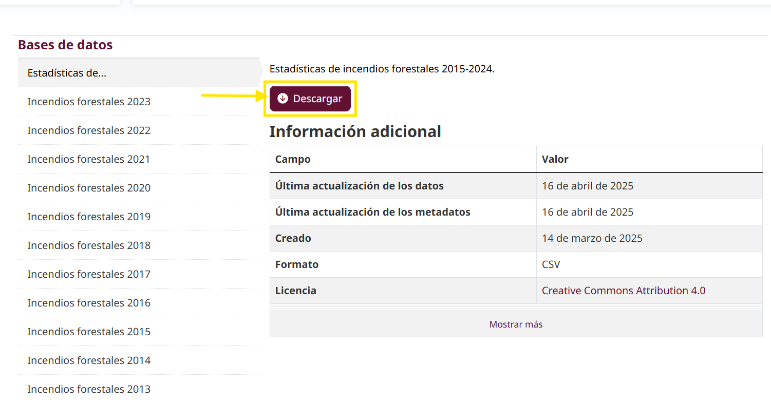

✔ Transform
- Column cleaning and normalization
- Typing: dates, numerics, strings
- Validations:
  - Numeric ranges (affected area, temperature, etc.)
  - Null values
  - Geographic consistency (states/municipalities)
✔ Load
- Output stored in curated/ zone, optimized for analytics
- Standardized column names
- Recommended final format: Parquet (compressed, columnar)

🔒 3. Quality Controls (QA)
Control | Purpose | Action
Hash & Metadata | Verify data integrity | Store hash in metadata/
Schema Check | Validate expected columns | Fail pipeline if critical columns missing
Null Threshold | Detect data quality issues | Alert if >10% missing in critical fields
Statistical Ranges | Catch outliers/errors | Compare against environmental limits
Duplicate Check | Avoid duplicate events | Remove duplicates by ID + date + state
Geospatial Validity | Validate location | Cross-check against INEGI state/municipal catalog

📦 4. File Storage Architecture
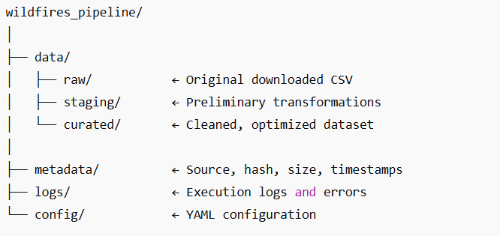

⚠️ 5. Risks & Mitigation
Risk | Impact | Mitigation
URL change | Pipeline failure | Use local fallback + alert
Outdated dataset | Model accuracy | Quarterly manual monitoring
Outliers / anomalous values | Bias in models | Apply statistical/environmental rules
Geographic inconsistencies | Analysis errors | Validate against INEGI catalog
Unclear license | Legal risk | Maintain source attribution and public usage

🔮 6. Next Dataset Candidates
Source | Dataset | Use
CONABIO | Vegetation types | Terrain vulnerability analysis
SEMARNAT | Emissions from fires | Environmental impact
SMN | Meteorological variables | Risk prediction
INEGI | Municipal boundaries | Geospatial validation

🎯 7. Value Proposition
This pipeline enables:
- Historical and regional analysis of forest fires
- Predictive risk modeling
- Assessment of forest damage by vegetation type
- Resource prioritization for emergency response
- Integration with climate and emissions data

